

Version 1.0.0

June 21, 2022

Pi daily monitoring support_internal

# Summary of Changes

|  |  |  |
| --- | --- | --- |
| Change | Version | Owner |
| Initial Version | 1.0 | Lavanya Gopal |
|  |  |  |
|  |  |  |
|  |  |  |
|  |  |  |
|  |  |  |
|  |  |  |

Contents

Summary of Changes 2

1. Purpose 4

2. STEPS TO VERIFY SUCCESSFUL DATA INGESTION 4

3. FLOW DIAGRAM 8

# Purpose

The purpose of this document is to provide detailed description of the steps involved, to monitor and report issues, for the Daily Pure Insights Data Ingestion process.

# STEPS TO VERIFY SUCCESSFUL DATA INGESTION

1. Verify if you received the below email before 6:30 AM EST

From - SOA PAX PI Data Ingestor <[no_reply@maximus.com](mailto:no_reply@maximus.com)>

Subject - PUREINSIGHTS_PRD: PI Data Ingestion Successful

1. Verify if all 28 projects are listed with ‘INGESTION COMPLETED’ or ‘INGESTION COMPLETED REINGEST’ status in the above email
2. If both Steps 1 and 2 are verified and all is as expected, no further action is needed
3. If you do not receive the email or if all projects are not listed with ‘INGESTION COMPLETED’ or ‘INGESTION COMPLETED REINGEST’ status in the email, please execute the following script –

use role PI_DATA_INGEST_PRD_ALERT_USER;

use warehouse PUREINSIGHTS_PRD_LOAD_WH;

use warehouse PUREINSIGHTS_PRD_LOAD_DAILY_WH;

use database PUREINSIGHTS_PRD;

**--The following query will provide file counts by project for projects that have files whose ingestions have**

**--not completed:**

**SELECT** * **FROM** ADMIN_PI_FILES_TO_INGEST_CURRENT_SUMMARY_BY_PROJECT_VW **WHERE** num_files != num_complete **ORDER** **BY** projectname;

**--The following query will provide file counts by project and table for projects that have files whose**

**--ingestions have not completed:**

**SELECT** * **FROM** ADMIN_PI_FILES_TO_INGEST_CURRENT_SUMMARY_BY_PROJECT_TABLE_VW **WHERE** num_files != num_complete **ORDER** **BY** projectname;

**--The following query will provide overall file counts for the ingestion:**

**SELECT** * **FROM** admin_pi_files_to_ingest_current_summary_vw;

**--The following query will provide overall file counts by table for the ingestion:**

**select** * **from** ADMIN_PI_FILES_TO_INGEST_CURRENT_SUMMARY_BY_TABLE_VW **WHERE** num_files != num_complete **ORDER** **BY** table_name;

**If failures have been detected in the counts, then the following query will provide information about the associated error messages:**

**SELECT** * **FROM** pi_files_to_ingest_current_vw **WHERE** status = 'FAILED';

**NOTE: The following error should eventually be resolved by the ingestion:**

**“Transaction was aborted because the number of waiters for this lock exceeds the maximum”**

**All other errors should be reported to the DEV team.**

Please note that the same information above should also be coming through in the form of an alert email–

From - "MAXDAT Distribution Services" <[noreply@maximus.com](mailto:noreply@maximus.com)>

Subject - ALERT! PRD - Pure Insights Ingestion Daily Job Not Complete

1. If both SUCCESSFILES_LOAD_COMPLETE and INGESTION_JOB_COMPLETE columns are ‘N’, please raise the issue with [support@mypureinsights.com](mailto:support@mypureinsights.com). Copy [LavanyaGopal@maximus.com](mailto:LavanyaGopal@maximus.com), [SyedHussaini@maximus.com](mailto:SyedHussaini@maximus.com), [SoundararangamRangarajulu@maximus.com](mailto:SoundararangamRangarajulu@maximus.com), [PatPCrider@maximus.com](mailto:PatPCrider@maximus.com), [JeromeHampson@maximus.com](mailto:JeromeHampson@maximus.com), [PulinKShah@maximus.com](mailto:PulinKShah@maximus.com)
2. Please notify about this issue on at the earliest and send a text message to Client Engagement Team contact person on the spreadsheet available under ‘After Hours Contact’ tab. Make sure to let them know that the issue has been raised with PI (if applicable)

Please note that the ‘First Contact Name’ information on the spreadsheet changes every week. Make sure to contact the person noted for that week/day.

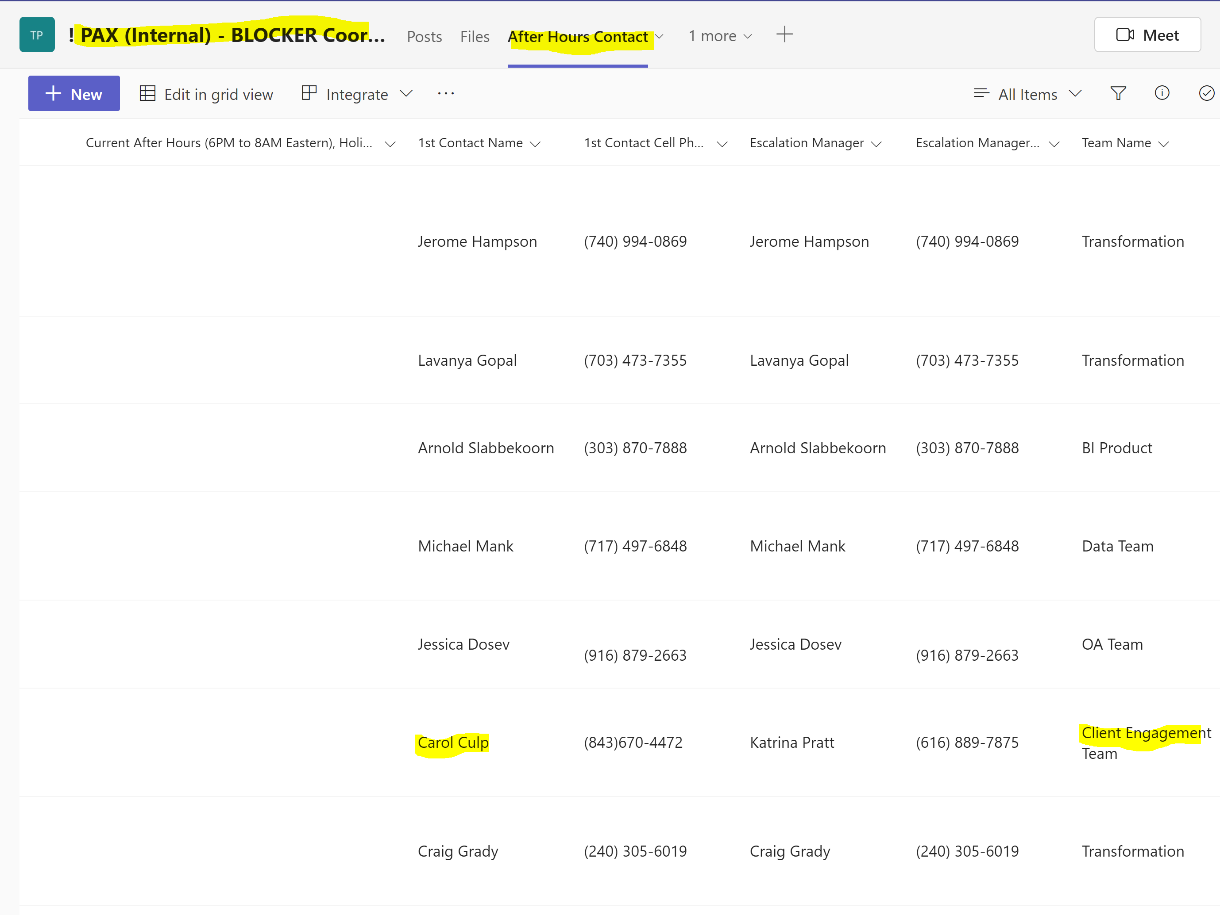

1. If SUCCESSFILES_LOAD_COMPLETE is ‘Y’ and INGESTION_JOB_COMPLETE is ‘N’, then, we do not create a ticket with PureInsights, but all the other stakeholders need to be notified as indicated in Step 6. Also, please reach out to someone from the development team to analyze and fix the issue.
2. Once the above issues are fixed, please notify Jerome / Pulin to refresh the impacted cubes.
3. After the cubes are refreshed, and data is available, notify DP4BI to coordinate with projects as needed.



# FLOW DIAGRAM

